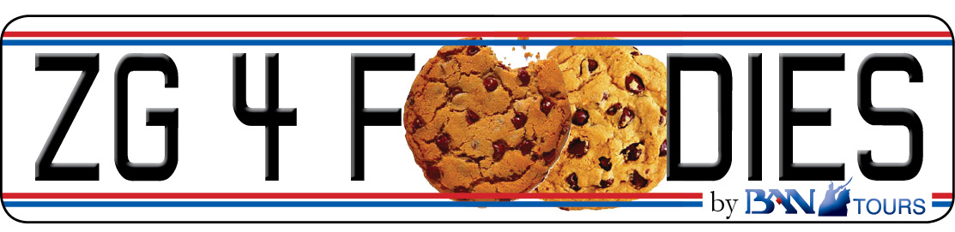

CROATIA - the new HOT SPOT 4 FOODIES. Be a trendsetter! Visit Croatia NOW, before the growing buzz attracts the tourist flocks.
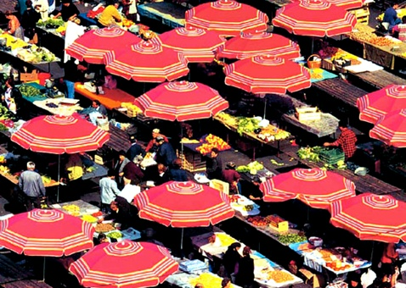  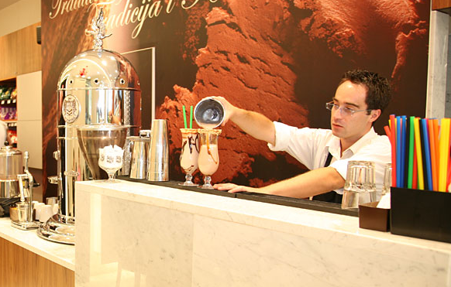  PRICE PER PERSON: | Zagreb Gourmet Walking Tour  Departures: daily at 10:00 a.m.; YEAR ROUND  Duration: approx 4 hours  Language: French, English, Italian, German  Min 2 persons – Max 10 persons  48h announcement necessary  Itinerary  Your guide will meet you in front of Gradska Kavana Restaurant & Café on the main city square and give you the short introduction in city’s cultural and gourmet background before you reach Dolac – the most picturesque open air market in the city.  In just few steps you will be in front of the Cathedral of St. Stephen and Archbishop's towers and halls. Following the Kaptol Square and neighboring streets you will get to famous Tkalciceva Street – pedestrian zone with plenty of cafés, restaurants, gourmet shops and galleries. The route will lead you further to stone pebbled Radiceva Street and The Stone Gate - remaining of strong city walls. Now, you will enter different, enchanting Zagreb returning back to 15th and 16th century. Step by step you will discover all major sights of Upper Town: St. Catherine's Square with baroque church, St. Mark's Square with House of Parliament, House of Government and St. Mark's Church with it's picturesque roof arriving panoramic spot beneath The Lotrscak Tower. Return to Lower Town by funicular.  Coffee break and sweet refreshment in Kraš Choco Bar – owned and managed by famous Croatian chocolate and sweets factory celebrating 100th anniversary.  Following the streets of Lower Town, passing Flower Square towards the Marshal Tito Square with three important landmarks of Zagreb: The Mimara Museum, Croatian National Theatre and Zagreb University. For the end of the tour you will follow the Lenuci’s “green horse-shoe” – 3 impressive squares and parks, passing the building of State Archives in Art-Déco style, Botanical Garden, and the Zrinjevac Park with a lot of buildings representing the typical architecture of Central Europe from the edge of 19th and 20th century. Buildings of The Croatian Academy of Science and Arts and neighboring Art Pavilion are two finest examples.  For the end of the tour you will taste famous Zagreb strukli (a pastry filled with mixture of cheese with eggs, sour cream and salt, covered in clotted cream and baked in oven) with a glass of wine in Le Bistro in The Regent Esplanade Hotel, a shining star at Zagreb gourmet scene.  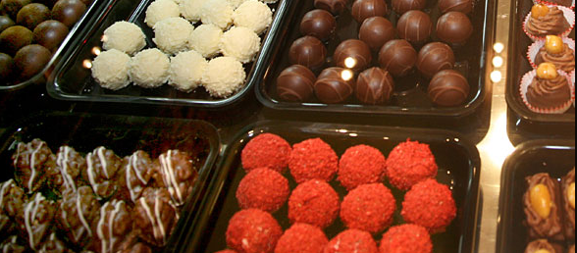  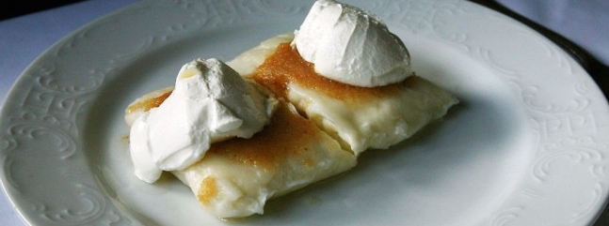
  Number of person | Price
  2-3 | € 115
  4-6 | € 75
  7-10 | € 50
  Tour includes:
  - Licensed City Guide for a Zagreb Gourmet Walking Tour according
  the itinerary
  - Coffee break
  - Funicular ticket
  - Snack (a pair of strukli – typical local meal, glass of wine)
  Tour Highlights:
  - The best gourmet places (restaurants, cafés, pastry shops, wine
  shops, gourmet shops, …)
  - Famous Zagreb sites and landmarks: Ban Jelacic Square, Dolac
  Market, Kaptol Square with Cathedral, Tkalciceva Street, The Stone
  Gate, St. Catherine's Square, St. Mark's Square, The Lotrscak Tower,
  Ilica Street, Flower Square, Masarykova Street, Marsal Tito Square,
  Lenuci’s Green Horse-shoe (Zrinjvec Park, Botanical Gardens,
  Mazuranic Square)
  - The shortest funicular ride in the world
  - Typical flavors of Zagreb

BAN TOURS d.o.o. • Kaptol 11, 10000 ZAGREB • ID code: HR-AB-01-1-61509 • www.bantours.hr
Phone: +385 1 48 81 800 • Fax: +385 1 48 14 677 • e-mail: incoming@bantours.hr

